Module 3 Assignment - History of Computer Architecture
SDEV120
Jamie J Williams

John von Neumann in his short 54 years of living contributed extensively to STEM fields that included mathematics, statistics, computing, economics, and physics. Von Neumann was pioneered quantum physics, mathematical framework, functional analysis development and in game theory, introducing or codifying concepts including cellular automata, the universal constructor, and the digital computer. His analysis of the structure of self-replication preceded the discovery of the structure of DNA. (Wikipedia, 2026, p.1)₁
John von Neumann in 1945 worked on the Manhattan Project whose purpose was to develop nuclear bombs. It was while working on the Manhattan project and his exposure to ENIAC programmable computers that von Neumann authored a report titled “First Draft of a Report on the EDVAC” that describes the concept of incorporating memory in a store-program computer.(HistoryTools, 2024, p1)₂
Architectural Diagram
Diagram 1 is the architectural diagram of the Von Neumann Architecture published by John Von Neumann in 1945 and as illustrated on the ComputerScience.GCSEGURU website and revised on April 16, 2019
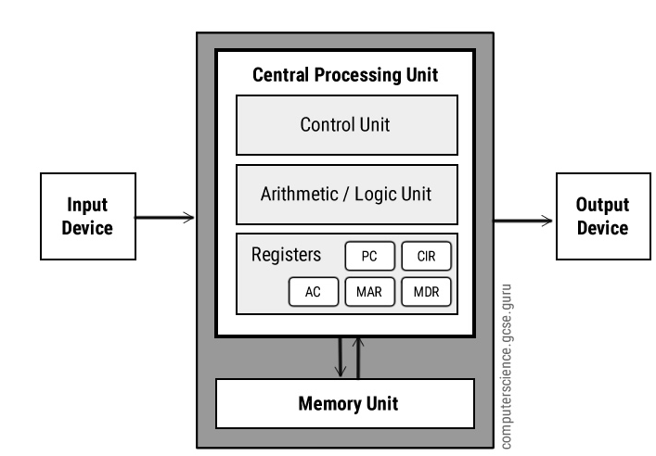
Diagram 1. Von Neumann Computer Architecture ₃
Computer Architecture Elements
The elements within the von Neumann computer architecture are comprised of a CPU which contains the control unit (CU), arithmetic logic unit (ALU), memory unit (MU), and the register set. The register set is comprised of the Program Counter (PC), Instruction Register (IR), memory address register (MAR), memory data registers(MDR), current instruction register (CIR). Input/Output (I/O) devices can be comprised of multiple devices to allow the user the ability to interact with the computer. Internal and external addresses, data, and control buses facilitate communications. Each of these devices are discuss further below:
CPU: The CPU is the brains of the computer system. The CPU is comprised of the devices illustrated internally to the CPU in the above diagram which are the CU, ALU, and Register set with access to the external memory. The CPU provides internal data, control, and address bus lines to interconnect with each of the listed electronic devices within the CPU and with MU which is physically external to the CPU but internal to the computer. The CPU supports addressing and data communications external to the computer to I/O devices such as printers, monitors, and keyboards.
ALU: The ALU is just what the name implies. The ALU supports mathematical operations including add, subtract, multiply and divide and bit wise operations such as Bit OR, AND NOT, XOR, which supports decision making and shift left and shift right operations. The accumulator is within the ALU and the accumulator is where intermediate arithmetic and logic results are stored. (ComputerScience.GCSEGURU, 2019)
CU: The CU is comprised of the electronic logic gate circuits controlling ALU, MU and I/O operations based upon the binary instruction set the CPU supported. The von Neumann computer instructions were sequentially executed retrieving the next instruction address from the Program Counter. The sequence of execution is illustrated in diagram 2. (OpenCourseWare, 2017)₄
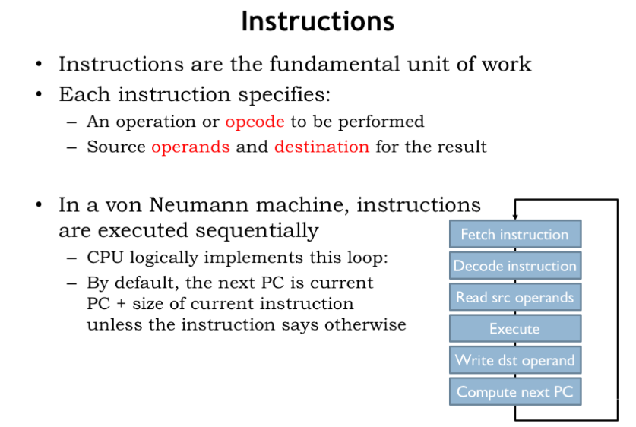
Diagram 2 von Neumann Instruction Execution₄

MU: The MU consisted of volatile memory also called Random Access Memory (RAM). RAM is directly accessible by the CPU and has a fast response time. Data was loaded from a permanent hard drive (non-volatile memory) to RAM for the execution of operations—illustrated above in the CU section.
Von Neumann Register Set
The CPU register set was comprised of the following registers as well as general purpose registers.
MAR: Memory Address Register : Contains the memory address where the instruction data is located.
MDR: Memory Data Register: Contains the data fetched from memory for the current instruction to execute.
PC: Program Counter Register: Contains the address of the next instruction to be fetched from memory and executed.
AC: Accumulator Register: Within the ALU, this register stores the most current results of arithmetic and logic operations
CIR: Current Instruction Register: Holds the current CPU executing instruction.
Buses:
Three buses support inter CPU communications in the von Neumann architecture and are still in place today. Address, command, and data instruction sharing occurs via the buses.
Control Bus contains status signals from other devices as well as commands from the CPU for the purpose of controlling and coordinating computer operations.
Address Bus: dedicated set of electrical wires interconnecting between memory, the ALU, and control unit that only carries addresses used to locate specific memory locations containing the instruction data. The address is placed on the address bus upon retrieving the next operation’s address from the PC.
Data Bus: dedicated set of electrical wires interconnecting between memory, registers, and the CPU and only carries data information. Data information transfers from the current address location via the data bus during the fetch instruction cycle.
Input/Output Devices:
Input devices allow the user to send requests to the CPU. Output devices receive the results of the input requests. Input devices could be a scanner, keyboard, or a magnetic or paper tape reader. Output devices could be a terminal screen, printer, or teletype.
Significance
Significance of the von Neumann computer architecture is the fundamental design incorporated the basic constructs for a store-program implementation during the 1940’s and those constructs are still in place today. This fundamental design led to the creation of desktop PCs, laptops, tablets, and smartphones. These modern day devices incorporate the von Neumann architecture some 80 years later indicating a robust, flexible, architecture. Despite technology advancements, the von Neumann architecture has stood the test of time.

References
- John von Neumann in Wikipedia, 19 June 2026, John von Neumann - Wikipedia
- “The Complete Guide to Von Neumann Architecture” in History Tools, March 27,2024, The Complete Guide to Von Neumann Architecture - History Tools
- Von Neumann Architecture in ComputerScience.GCSE.GURU, April 22, 2016 & modified April 16, 2019, Von Neumann Architecture - Computer Science GCSE GURU
- Computation Structures Section 15 in OpenCourseWare, Spring, 2017, 9.1 Annotated Slides | Computation Structures | Electrical Engineering and Computer Science | MIT OpenCourseWare

